**Project Proposal: SportZ**

**Team Sportz**

Lin Zixing, U2021976K (Project Manager/Release Manager)

Fabian Wong, U2021617L (Lead Developer/Release Manager)

Chia Songcheng, U2021738F (Front-end Developer)

Lim Sheng Zhe, U1922742H (Back-end Developer)

Chew Poshi, U2022913H (Back-end Developer)

Chee Zi Hoe, U2023270C (QA Manager)

Hermes Lim HongJun, U2022436C (QA Engineer)

Team SSP2 Group 4

Nanyang Technological University, Singapore

Submitted to Sports Singapore

Dr Elmie Nekmat

Assistant Professor, Communications and New Media, NUS

# Table of Contents

Contents

Table of Contents 1

1 Executive Summary 2

2 Statement of Problem 3

3 Objectives 4

4 Technical Approach 5

4.1 Plan of Action 5

4.2 Customer Needs 6

4.3 Target Specifications 6

4.4 Technology Consideration 7

4.5 System Architecture/Platform 8

4.6 System Architecture Diagram 9

5 Project Management 10

6 Deliverables 11

7 Budget 12

8 Communication and Coordination with Sponsor 12

9 Team Qualifications 13

References 15

Appendix A: Resumes 16

# 1 Executive Summary

In recent years, Covid-19 has taught us the importance of valuing one’s health and the importance of leading a healthy lifestyle. With the safety-measurement restrictions put in place for the safety of others, it has resulted in the decline of the playing of sports. As the pandemic situation stabilizes within Singapore, measures are slowly lifting, allowing for larger groups to gather. As such, our team aims to develop a Game Development Project as part of the ActiveSG movement to promote healthy living through sports.

Our team’s objective is to develop a 2D Endless Runner game, SportZ, incorporating a variety of sports to garner interest in teenagers and young adults to participate in sporting activities. Through the playing of SportZ, teenagers and young adults will be intrigued about playing sports in real life and would be thus motivated to try out new sports.

The project comprises a single game software, primarily developed using the game engine editor Unity3D, with Figma for UI and mockup designs. Testing will be done continuously and in different stages. A prototype will be first developed to test the basic components of an Endless Runner game. The second stage will be to implement other mechanics such as player ability, enemies, obstacles, collectables and player upgrades. Assets will also be developed in this stage, such as art, animation and sound. The final stage will be to incorporate all components to ensure the game is playable from start to finish.

The game will be designed to be expandable, such that updates, and more content could be rolled out allowing further replay ability and unique experiences in each playthrough.

# 2 Statement of Problem

Sports play an important role in an individual’s life as it provides a means for individuals to relieve stress. However, due to the recent covid-19 global pandemic, it is harder for sports to take place which led to more people resorting to home workouts to keep their body in shape.

Despite the nation’s effort in trying to promote sports through sporting campaigns such as ‘GetActive! Singapore’ and ‘Let’s Get Moving Singapore’, it seems rather futile. This is due to the volatility of the current covid-19 situation, where imposed restrictions change regularly. On top of that, sports are played in groups and in proximity, coupled with the earlier mentioned reason, this decreases the likelihood of individuals playing sports.

With this in view, our team aims to promote sports through a game in hope to encourage individuals to indulge in the different sports in Singapore. Inducing a sporting culture is even more vital in today’s world as it enhances our immunity, strengthens our body, rebuild our social connections and improves our mental health. Current campaigning efforts made by the government are ineffective and we believe that through a game, it provides more insights as well as entertainment value to different groups of users.

There is a need for a digital platform that encourages users to try out new sports. Our game, SportZ strives to fulfill such a need by allowing users to interact with various sports and its elements throughout the course of the game in a slightly exaggerated but engaging manner. The game’s graphics and mechanics will encourage individuals to make an effort to try out new sports.

Team SportZ is composed of 7 capable individuals with ample software development experience and are able to build easy, maintainable and user-friendly applications in an agile manner. The issue that we are addressing is one that the team believes in and hence see the need for a change to be made, making Team SportZ the perfect team to tackle this problem.

# 

# 

# 3 Objectives

This document proposes a detailed and engaging 2D endless runner game: SportZ developed for the windows platform to tackle the problem as mentioned above.

The target audience will mainly be people who are interested in playing games. SportZ aims to encourage such individuals to indulge in a sporting culture. SportZ will require users to operate the game via a laptop/desktop with windows software installed.

The objectives of SportZ are listed as follows:

1. **The game must include multiple sports** - With a variety of sports included, this allows users to be exposed to a different number of sports. This will garner interest amongst users in the different sporting elements that they interact with.
2. **The player must be able to perform actions to interact with the game environment** - These actions allow the users to have a smooth and enjoyable gameplay experience through interacting with the various game elements.
3. **Platforms appear at random intervals and positions for players to jump on** - This provides a changing element that provides a higher engaging factor for users to have a more enjoyable experience playing the game.
4. **Platforms must be reachable by the player** - This is to ensure that the users do not have issues during their gameplay that would hinder their progress in the game.
5. **Having in-game boosts and power ups** - This is to allow users to have different types of temporal abilities or benefits which allows them to reach a higher high score.
6. **A health bar is lost upon contact with enemies or different environmental objects meant to hinder the player** - Users will have a health bar which is a measurement of the avatar’s hit points. Complete depletion of the health bar would result in the ending of the game. This provides replay ability for users to beat the high score.

# 4 Technical Approach

## 4.1 Plan of Action

The action that will be taken for this project will be separated into the following 4 main phases:

**Phase 1: Requirements Elicitation, Analysis and Designing**

This phase includes understanding the team’s strengths and identifying the customer needs. From here, we design a game that can properly utilize the strengths of each member and come up with various components and game mechanics that would match the customer’s needs. The team is separated into the programming team and the design team.

We also identify the various software to use for each component of the game and let the team members familiarize with the software prior to actual development. Additional documents are also created to ensure ideas are properly conveyed, and to enforce the consistency in creative approaches.

**Phase 2: Development**

In this phase, the fundamental design has been completed. The programming team will start to work on various mechanics laid out by the design team, which is made clearer with reference to a product backlog. The backlog consists of atomic tasks that can be undertaken by each team member to track progress for the project. Testing will be done continuously by the developers themselves, and at each point where a working version of the game is available.

**Phase 3: Testing**

The main bulk of development is to be completed by this point. Testing to be done to ensure the game is refined and bug-free. The QA team will enforce standards and communicate closely with the development team.

**Phase 4: Maintenance**

For the maintenance phase, patches to the game will be regularly rolled out to fix any further issues post release.

The team also expects to work on expansions and additional content for the game to be released on a regular basis.

## 4.2 Customer Needs

Living in the age of the internet, many people have access to desktop and laptops. Playing games on desktop and laptops have become a norm for many as a way of relieving stress as well as to pass time and hence we strongly believe that bringing this game to the market will be a game changer. With the combination of sporting elements as well as the interactiveness of our gameplay, we aim to target audiences from age 12-26 to promote sports among the youths in Singapore.

## 

## 4.3 Target Specifications

Having at least 2 types of sports in our game allows youths to explore the different types of sports available to them. For some, it may be a sport that they have not heard of and hence introduces them to new sports.

By enabling players to perform “jump” and “attack” actions as well as having random platforms spawning in the game adds complexity to the game which makes a game more interesting to play. These two actions are essentially the core mechanics of the game. This will make the game more appealing to the youths.

Having power ups and reachable platforms adds variety to the game and at the same time makes the game more playable.

Lastly, the obstacles in the games are all sports related obstacles and thus this will allow players to learn more about the sport when they are engaged in the game.

## 

## 

## 

## 4.4 Technology Consideration

**Table 1**: Technologies used for SportZ.

|  |  |  |
| --- | --- | --- |
| **Phases** | **Objective** | **Technology Used** |
| Phase 1 | Identifying Customer Needs | N.A |
| Preliminary Design | Figma, Google Docs, Microsoft Office |
| Software Familiarization | Unity3D, Piskelapp, GitHub |
| Phase 2 | Development (Programming) | Unity3D: C# |
| Development (Design and Prototype) | Google Docs, Microsoft Office, Unity3D: C# |
| Development (UI) | Figma, Unity3D: C# |
| Art, Animation and Sound | PiskelApp, Royalty Free Sites |
| Phase 3 | Testing | Unity3D: C#, Microsoft Office |
| Phase 4 | Maintenance and Updates | As per phase 1,2 and 3 where applicable |

## 

## 

## 

## 4.5 System Architecture/Platform

**Table 2**: Platform and tools SportZ

|  |  |
| --- | --- |
| **Platforms/Tools** | **Description** |
| Unity3D | Unity3D is used as our game engine for the creation of our game, SportZ |
| Figma | Figma is used to create the UI prototypes for our game. |
| Piskelapp and Royalty Free Assets | Piskelapp and Royal Free Assets is used for Art Assets |
| Royalty Free Music | Royalty Free Music is used for the sourcing of background music incorporated into the game. |
| Windows 10 OS | Windows 10 OS is the game platform which allows users to download our game and play. |
| Github | Github is used to host our code for version control and collaboration. |

## 4.6 System Architecture Diagram

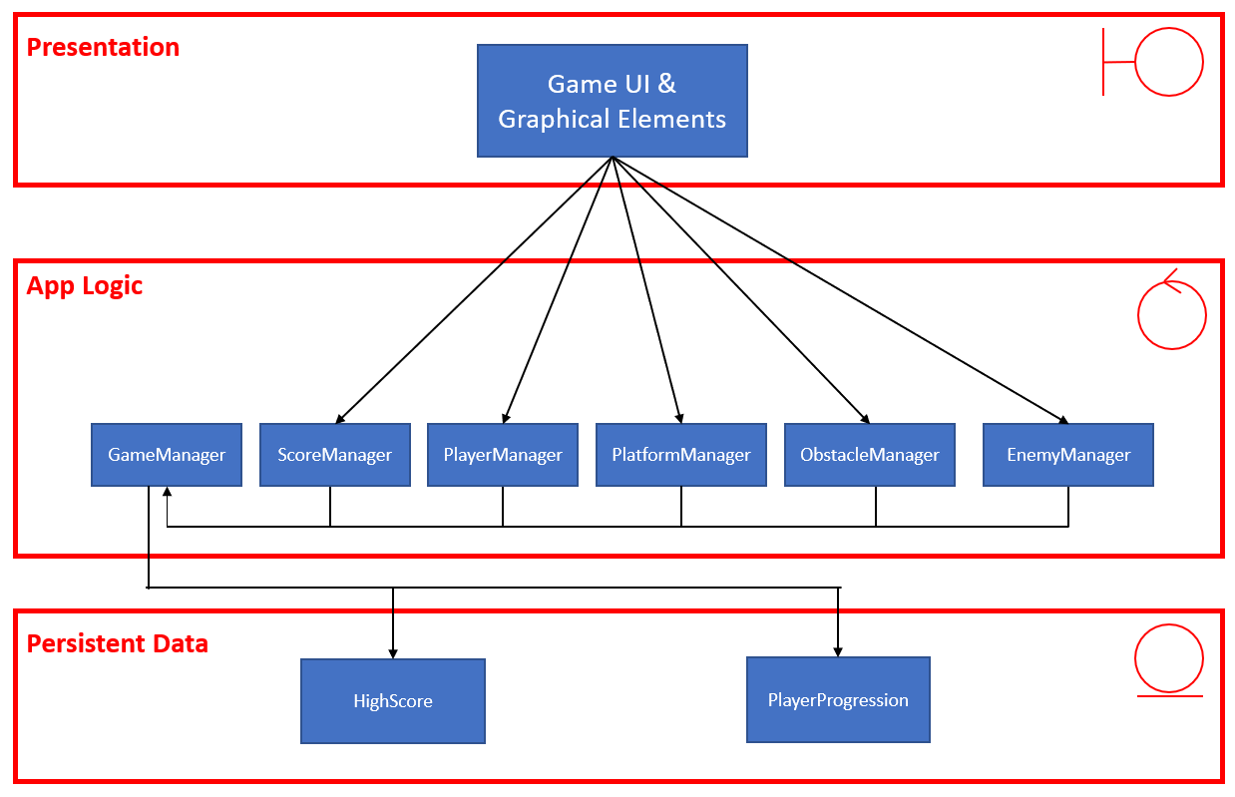

**Fig 1**: System Architecture Diagram.

# 

# 

# 

# 5 Project Management

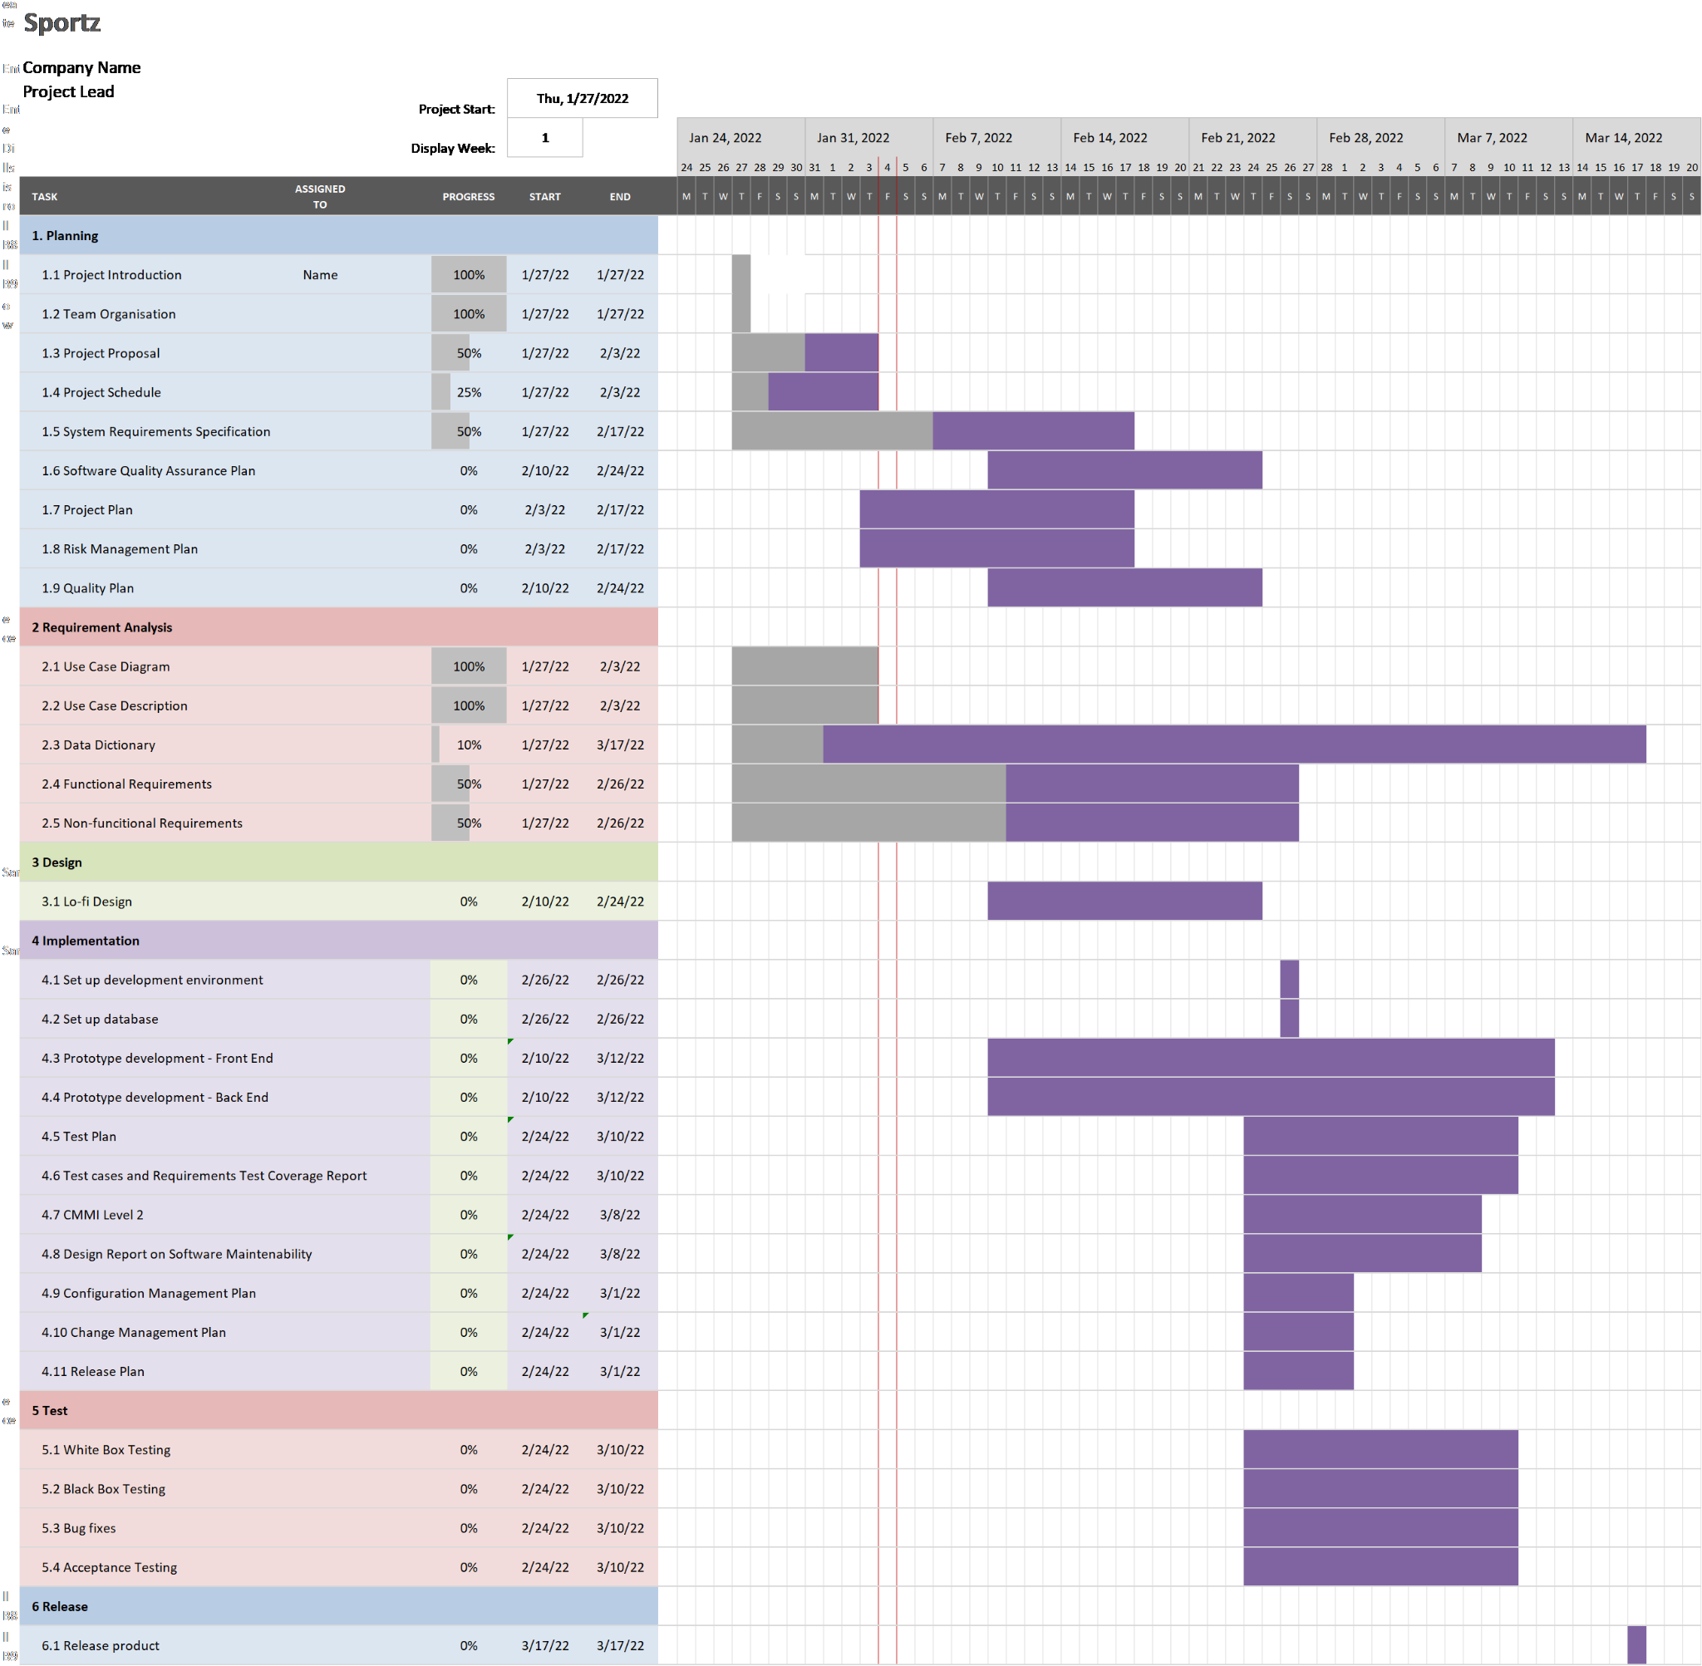

**Fig 2**: Gantt Chart for the project.

The Gantt chart above is used to plan and schedule while developing the game. Each task is organized into 6 sections mainly the Planning, Requirement Analysis, Design, Implementation, Test and Release. With the Gantt chart, we can gauge the progress of the team and have a rough idea of how long each task will be completed. The person that oversees the task will also be known, hence the flow of the project is better managed, and measures can be taken in the event where something unexpected happens and extra help is needed.

# 6 Deliverables

|  |  |  |
| --- | --- | --- |
| **Deliverable Item** | **Estimated Completion Date** | **Final Deadline for Submission to Stakeholder** |
| Project Proposal | 8th Feb 2022 | 10th Feb 2022 (lab 2) |
| Use Case Diagram and User Case Description | 8th Feb 2022 | 10th Feb 2022 |
| Initial Software Requirement Specification | 22nd Feb 2022 | 24th Feb 2022 (lab 3) |
| Quality Management Plan | 22nd Feb 2022 | 24th Feb 2022 |
| Software Model Prototype | 1st March 2022 | 17th March 2022 (lab 4) |
| Project Plan | 1st March 2022 | 17th March 2022 |
| Risk Management | 1st March 2022 | 17th March 2022 |
| Design Report | 21st March 2022 | 31st March 2022 (lab 5) |
| Configuration Management Plan | 21st March 2022 | 31st March 2022 |
| Change Management Plan | 21st March 2022 | 31st March 2022 |
| Release Plan | 21st March 2022 | 31st March 2022 |
| Test Plan and Documentation | 4th April 2022 | 14th April 2022 (2 Weeks after lab 5) |

## 

## 

# 7 Budget

The total estimated budget for the whole project is expected not to exceed $94,000 Singapore dollars. The fund will be used to carry out the development of the game across the 3 months which includes the planning stage all the way to the deployment stage.

The table below shows the breakdown of the requested items and funds per unit cost and total cost.

|  |  |  |  |  |
| --- | --- | --- | --- | --- |
| **Table 3:** Requested items and funds for initial design. | | | | |
| **Item** | **Supplier** | **Quantity** | **Unit Price** | **Total** |
| Project manager |  | 1 | $20,000.00 | **$20,000.00** |
| Project team members |  | 6 | $9000.00 | **$54,000.00** |
| Computers (Programmer) | Aftershock | 4 | $2000.00 | **$8,000.00** |
| Computers (Designer) | Aftershock | 3 | $1500.00 | **$4,500.00** |
| Printer | HP | 1 | $3,000.00 | **$3,000.00** |
| Office rental | NTU | 1 | $3,000.00 | **$3,000.00** |
| Transportation | Taxi | 1 | $1,000.00 | **$1,000.00** |
|  |  |  | **TOTAL** | **$93,500.00** |

# 8 Communication and Coordination with Sponsor

For effective and efficient communications with the sponsors of this project, we propose to have fortnightly meetings to provide consistent updates on our progress in developing our game. The meetings will be held physically in NTU; feedback given to us will be taken into account and further revisions will be made accordingly for further review. In addition to that, updates will also be available on MediaWiki.

## 

# 9 Team Qualifications

|  |  |  |
| --- | --- | --- |
| **Role** | **Name** | **Experience** |
| Project Manager/Release Manager | Lin Zixing | Zixing has great experience leading projects across different fields. He has directed diverse teams. managed different stakeholders and upheld project delivery. Being an experienced game developer, he is the ideal project manager for SportZ |
| Lead Developer/Release Manager | Fabian Wong | Fabian has great experience in teams in game design and game development. Having developed different games, he is an experienced and knowledgeable game developer. |
| Front-end Developer | Chia Songcheng | Songcheng has great experience in front-end development having great technical and design skills, making him a competent front-end developer. |
| Back-end Developer | Lim Sheng Zhe | Sheng Zhe has a strong background in working with databases as demonstrated by his projects, making him a suitable back-end developer. |
| Back-end Developer | Chew Poshi | Poshi has a strong grasp working with databases and this will make him a competent back-end developer. |
| QA Manager | Chee Zi Hoe | Zi Hoe has experience in QA processes where he tested our many applications and checked to ensure that the product was up to standard. |
| QA Engineer | Hermes Lim HongJun | Hermes has experience in testing performance and functionalities of software via black-box and white-box methodologies |

# 

# References

* Board Members of SportsSG: [SportSG | Our Board Members (sportsingapore.gov.sg)](https://www.sportsingapore.gov.sg/About-Us/Our-Board-Members)
* Game Developer career information and salaries 2021: [How to Become a Game Developer in 2021 | Career (careerkarma.com)](https://careerkarma.com/careers/game-development/)

# Appendix A: Resumes

Project Manager/Release Manager: Lin Zixing

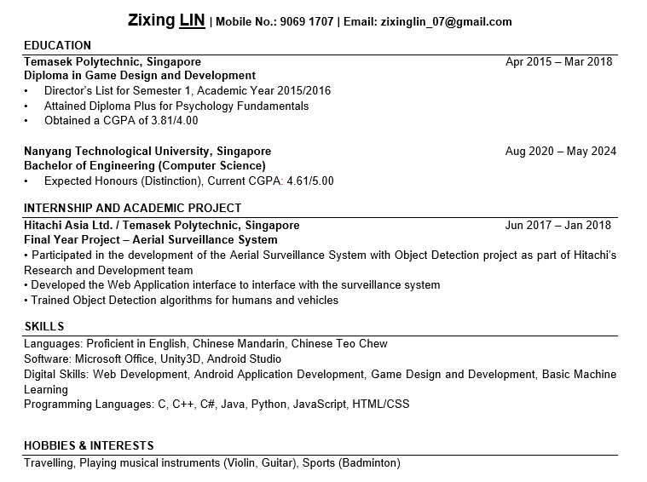

Lead Developer/Release Manager: Fabian Wong

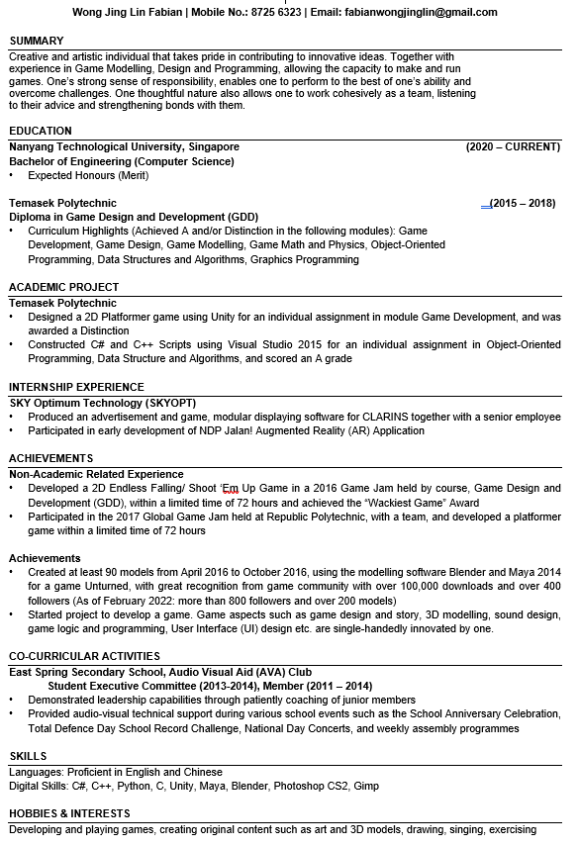

Front-end Developer: Chia Songcheng

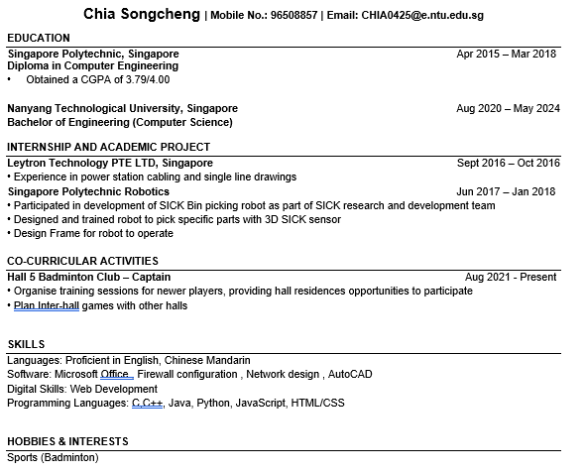

Back-end Developer: Lim Sheng Zhe

Back-end Developer: Chew Poshi

QA Manager: Chee Zi Hoe

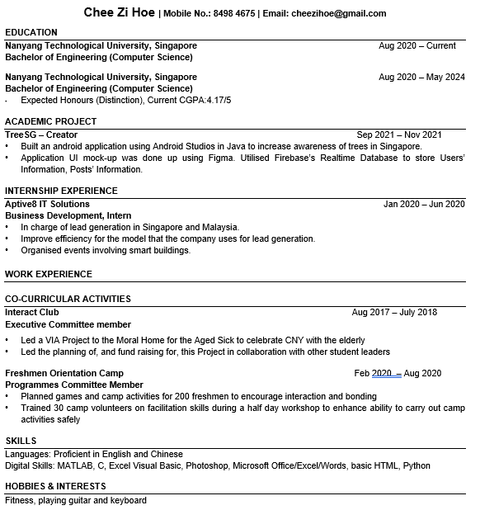

QA Engineer: Hermes Lim Hong Jun

